# VLF Antenna Construction

The purpose of this guide is to give basic instructions on how the loops of for the large loop VLF mast are to be constructed. The information in this guide is taken from the “VLF goniometer system for SANAE, Antarctica” instruction manual by A.J. Smith, and from personal experience. Required material: Please note that the amounts listed here are per single loop. Two would be needed per set for the mast.

## Material Requirements

|  |  |  |
| --- | --- | --- |
| Item | Amount | Notes |
| RG 231/U Coax Cable | 50 m | This approximate length, slightly longer or shorter should not affect performance if both loops are the same length. |
| 0.1 µF non-electrolytic capacitor | One | Installed at the top of the loop, making a gap in the sheath (refer to sketch). |
| N-Type connectors | Two | To connect both side of loop to instrument. The reusable screw type is suggested. |
| Resin joint kit | One | To protect and reinforce capacitor at top of loop. |
| Rope thimbles (non-magnetic) | Three | Used to secure the top and sides of the loop. It is important the fibre rope and steel wire rope thimbles are used, to prevent the thimble from damaging the rope. |
| Plastic/Aluminium disks | Two | Used to secure bottom of loop to mast. Refer to rest of the guide for details. |
| U bolt clamps (non-magnetic) | Five | Secure the rope to the thimble and disk. |
| Rope | Unknown | The rope is used to connect the thimble and disks to the loop. |
| Heat-shrink and/or self-amalgamating tape | Unknown | Used to where the ropes are connected to the loops, thimbles and disks. |

## Construction

The construction of a loop will be described using the picture below, following the order as indicated by the red circles and numbers. Take note of the distances of the sides as indicated on the sketch during construction.

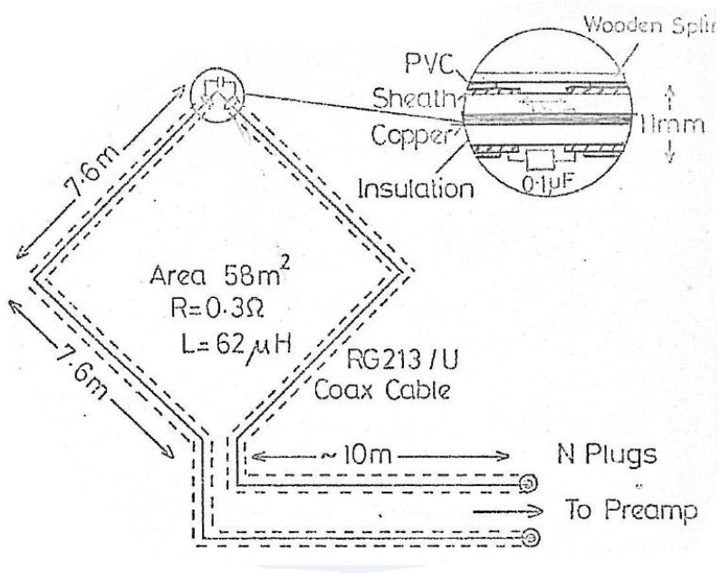

Figure 1. Schematic for VLF loop construction.

### Point 1

Gap capacitor - At the top of the loop (middle of the 50 m cable), take off a short portion of the insulation (around 50 mm) and make a cut through the outer copper sheath in the middle of the exposed section. Make the copper sheath on both sides of the cut into bundles and solder the capacitor between these two points. Cover the area with insulation tape if so desired and then use a resin joint cut to seal and strengthen the capacitor area. Top loop suspenders – With the use of the rope, thimble, U bolt clamp and tape construct a suspender for the top of the loop, as seen in the picture below.



Figure 2. VLF loop construction - Point 1.

### Point 2

Top loop suspenders –At the points 7.6 m from the centre of the loop, construct the side suspenders of the loop, as per the method followed at point 1. The second picture below shows how the side suspenders are used to achieve the diamond shape of the loop.



Figure 3. VLF loop construction - Point 2.

### Point 3

Bottom loop connectors –At the points 7.6 m from the centre of the side suspenders, the bottom loop connectors are attached to the mast, with the use of round disks. These disks may be constructed from plastic or aluminium disks (only non-magnetic materials), with a groove around the outer edge to guide and hold the rope. The outer diameter of the disk shown below is 40 mm, but this is not an important measure. The diameter of the hole through the disk is 10.7 mm. This hole must be between 10.5 mm and 11 mm.

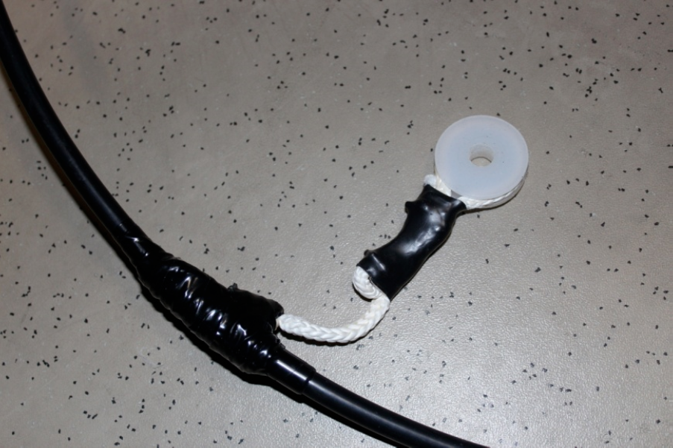

Figure 4. VLF loop construction - Point 3.

### Point 4

N-type connectors – Connectors at the ends of the loop connect it to the instrument. The reusable screw type connectors are suggested.

## Troubleshooting

The loops should be located as high as possible on the mast and NOT be pulled tight as this will cause vibrations on the loops and damage to the loops. The stay ropes of the antenna mast should remain tight and to aid in tightening these stay ropes the best technique was found to insert an alpine butterfly above the alpine butterfly made for the trucker’s hitch and use a winch to tighten the stay rope. Once the winch has pulled the stay rope as tight as desired the trucker’s hitch can be tightened and secured where after the winch is released. Do this procedure on both sides of the mast preferably at the same time as to not cause the mast to lean to one side or the other. After heavy storm, it’s advisable to go to sciences area to check if there’s the loops are in good conditions. Adjust stay ropes where it’s necessary.